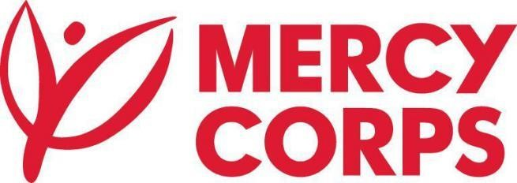

**Request for Proposal**

**Project/Consultancy Title: Localization and translation services for MicroMentor Somali platform** **Project Location(s): Ethiopia**, **Somalia and Kenya**

**Background:**

MicroMentor is an initiative of the Mercy Corps Innovations Team. At MicroMentor, our mission is to leverage the power of mentoring to help small businesses thrive. We do so by offering entrepreneurs direct access to a pool of committed professional volunteer mentors via an easy-to-use online community. MicroMentor has an expanding community making 10,000 mentoring connections every year. Entrepreneurs matched with a mentor have shown significant results in terms of improved job creation, business survival, and revenue growth.

**Purpose / Project Description:**

Mercy Corps is aiming to launch MicroMentor, a global mentoring platform, in the Somali region of Ethiopia. In order to have the appropriate web site to serve local entrepreneurs and mentors, we are looking for a firm highly experienced in web site content translation and localization process to adapt to Somali contexts.

For this work, MicroMentor would prefer to collaborate with a company/consultant that is familiar with building websites in Somali. MicroMentor does not need web design, but needs localization for the context of our platform. A web design firm with this experience is the best place to find translation both contextually appropriate for a website as well as culturally appropriate for Somali speakers using the site. The expertise of a web design firm will also have in-house capacity in entering some of the content directly into our CMS (Wagtail).

**Objective:** Localize and translate the MicroMentor platform content into Somali, with input from the local team for editorial voice and style.

**Consultant Activities:**

The consultant will:

1. Localize a .PO file from English to Somali.
2. Localize spreadsheets of text from English to Somali, and enter that text directly into the MicroMentor CMS (Wagtail).
3. Assist in validation testing of their changes in staging and eventually production environments.
4. Provide functional Quality Assurance (QA) targeting Somali specific functionality
5. Provide linguistic QA, more specifically focused on linguistic issues (translations in context).
6. Integrate field localization feedback from MicroMentor team, who will verify communication style/tone of voice, and make appropriate updates.
7. Takes due consideration of the cultural context while translating the content into Somali language to make sure translation is appropriate and acceptable by the user community

**Consultant Deliverables:**

The consultant will deliver:

1. Files of translated text (some in .PO format, some posted directly into our CMS) -- an estimated 30-35k words.
2. Translation/recreation of 4 PDFs into Somali (word count included in above estimation) 3. Assurance of the linguistic and functional quality of any delivered text in the above formats.

**Timeframe / Schedule:**

4-5 weeks from the date of hire to date of Final Delivery.

* We expect that the firm share an early advance (after 2-3 days of starting the work) for a quality assurance check with Mercy Corps local team.
* To have the first version of the PO. File and CMS pages the firm will have 4 weeks to deliver.
* We expect 1 week for final reviews/corrections

**To apply to this consultancy:**

* Along with your application, please share examples of your previous work (Somali localization websites)
* Demonstrated experience in conducting translation and localization of detailed content to Somali language (web content is highly preferred)
* Provide the translation of the below two paragraphs along with your application:

|  |
| --- |
| *What is MicroMentor? A global community of mentors and entrepreneurs.* |
| *A program of Mercy Corps, MicroMentor's easy-to-use social platform enables the world's largest community of purpose-driven entrepreneurs and business mentors to create powerful connections, solve problems, and build successful businesses together. We strive to overcome geographical limitations and deliver business resources at scale to underserved communities around the globe through mentoring.* |
| *Strong mentoring connections lead to better business outcomes.* |
| *For entrepreneurs, turning a passion into a business is the ultimate dream. But that dream doesn’t come easily. It’s hard work, and there are challenges around every corner. For mentors, sharing their hard-won knowledge with entrepreneurs who are just starting out is its own reward. MicroMentor is where they meet. It’s an easy-to-use service provided at no-cost that connects entrepreneurs with volunteer mentors so they can solve problems and build businesses together.* |

Criteria:

* Being an eligible business under the Ethiopian laws and regulations; and attach renewed Business license.
* Being in good standing with any Ethiopian taxation or legal authority; and which can submit Value Added Tax (VAT) registration and Tax Identification Number (TIN) certificate.
* Having a satisfactory record of performance and business ethics based on information available to Mercy Corps.

Submission:

* Detailed technical and financial proposal (separately) should be sent to

[et-tender-questions@mercycorps.org](mailto:et-tender-questions@mercycorps.org) till September 2nd 2020 5:00pm;

* Proposals sent by other email account will be disqualified
* Proposals received after this date will not be considered.
* Mercy Corps reserves the right to reject the bid fully or partially;

**The Consultant will report to:**

*Sr. Project Manager*

*Local Ethiopia Team*

*And work closely with Senior Digital Manager and Global Programs Coordinator*