QUALITY CONTROL PLAN
PR #: ABV PR 5287 | Tender #: NIG/ABV/TEN40
PR Description: Supply, Delivery and Installation of Cocoons to Gombe State, Nigeria

Essential Specifications and Testing Requirements

- Material – Reinforced Polyvinyl Chloride (PVC)
- Thickness – 0.83 mm
- Dimensions – 5.95 x 4.35 x 3m
- Capacity – 50 MT
- To be supplied with carrying bag and repair kit, Grain shed and manual with inlet and outlet port

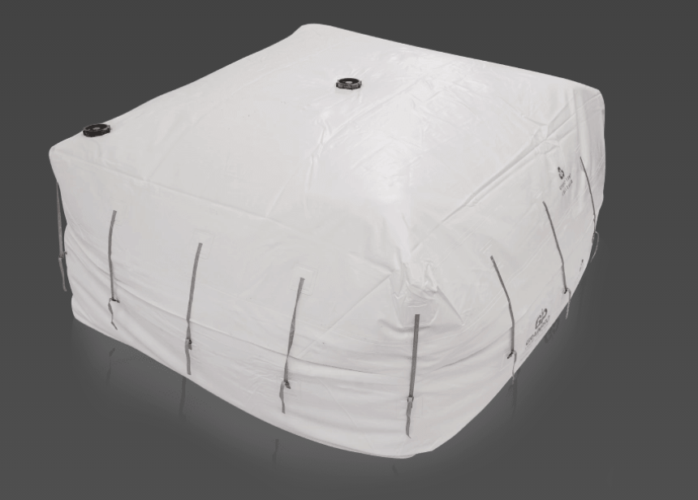

Contract Testing Requirements

- On receipt of the shipment in Nigeria, a full inspection of the order will be performed for compliance with the specifications and standards
- Inspection of the shipment will be performed by a committee with representation from both Mercy Corps Nigeria respective program team and from its partner CropIT
- The inspection will be followed by acceptance if all the items meet our main technical standards as spelt out in the quality control plan OR will result in rejection for non-complying items
- For the inspection of the complete shipment, the below standards will follow which will base the acceptance or rejection of the order;

Percent of items to be tested - Sampling size -  (%) | Frequency | Percent of tested samples that needs to fail for the entire order to be considered non-conforming  (%)
10% | On receipt – per item | 10%

Non-Conformance

In case of non-conformance to agreed quality standards, the below actions will enforce;

- If more than 10% of the sampled 10% is non-conforming, the whole shipment is returned and delay penalties will be enforced if applicable
- If less than 10% of the sampled 10% is non-conforming, the vendor should provide Mercy Corps with quantities equal to the percentage of the non-conforming items sampled, times the whole quantity
- Payment will only be processed after the delivery, inspection and acceptance of all items.

