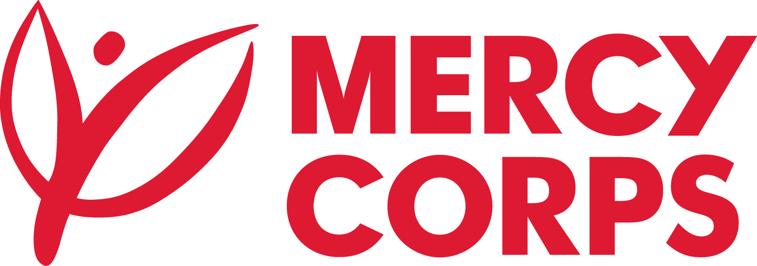
Date: November 03, 2023
Reference: MAR-RFB-HRT-002
Tender Notice
Mercy Corps is a non-religious, non-profit and non-governmental international humanitarian organization.

Mercy Corps is seeking suppliers for the supply of non-food items (NFIs) such as Hygiene Kits, Dignity Kits, cash-for-work (CFW) kits, Winterization Kits, Cleaning Kits and Consumable Kits at Herat, Balkh and Kandahar Provinces of Afghanistan.

If you are interested in submitting a bid, you will need to complete an Intent to Form and submit it according to the guidelines below.
- The suppliers can download the Intent to Bid Form on this link https://www.acbar.org/site-rfq or www.mercycorps.org/tenders
- Intend to Bid Form can also be picked up at Mercy Corps offices:
Herat: House 34, Herat university road, District No # 1.
Kabul: H. 31, Herati Street, Shar-e-Naw.
Kandahar: House # 54, Street S, Road 2, Aino Maina.
Completed Intent to Bid Forms must be submitted to Mercy Corps by 13 November 2023 in one of the below methods.
- Email completed Intent to Bid Form to af-tender@mercycorps.org with the Tender Reference number in the email subject line.
OR
- Return completed Intent to Bid Form in person and put in the Tender Box placed at Mercy Corps office Herat, Kandahar and Kabul. The Tender Reference number should be written in the envelop.
After the closing date of this Tender Notice, the Request for Bid will be sent to the suppliers who submitted Intent to Bid Forms. The Request for Bid will be sent according to the preference you have mentioned in the Intent to Bid Form.

