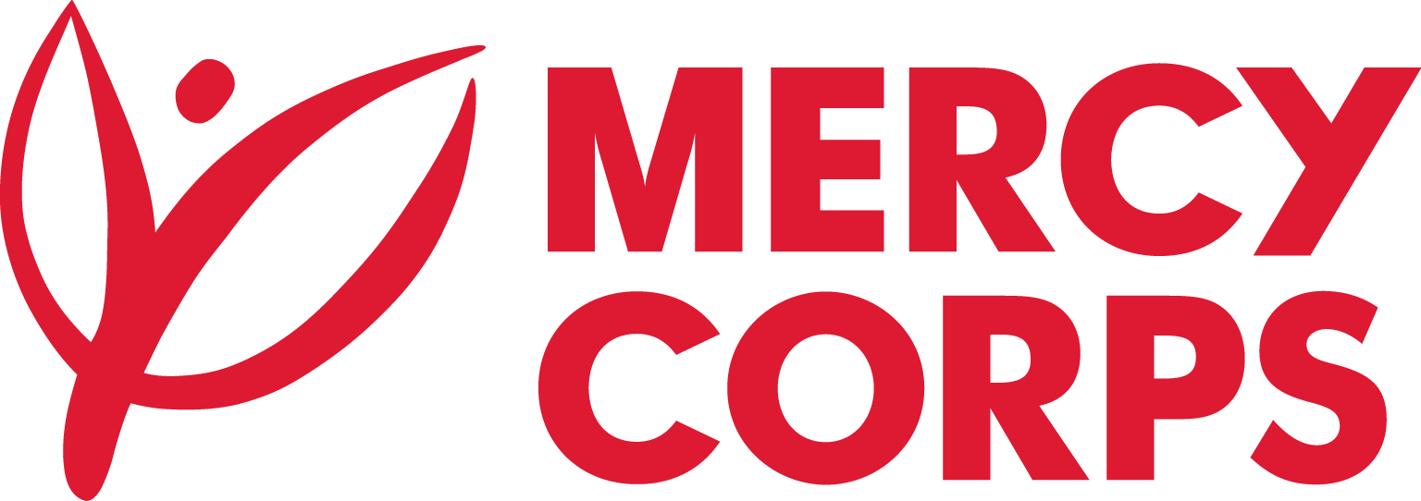
Date: July 08, 2024
Reference: DAO/MCML/CIT/BKO/2024/0005
CONSTRUCTION OF 10 INFRASTRUCTURES:
- Construction of one (01) basic water supply system at Benena in the Tominian circle, San region;
- Construction of two (02) village hydraulic systems at Hanekuy and Dobwo in the Tominian circle, San region;
- Conversion of a Human Powered Pump into a solar pumping system at Waramata in the Tominian circle, San region;
- Development of four (04) market garden areas in Kio, Souneni, Diarani and Batienso in the Tominian circle, San region;
- Rehabilitation of a fish pond at Koula in the Tominian circle, San region;
- Construction of a storage warehouse in Tominian in the communes of Tominian, Benena and Koula in the cercle of Tominian, San region.

Tender Notice
Mercy Corps has been working in Mali since 2012 implementing projects / programs that contribute to the humanitarian response in the northern and central regions of the country with a vision to help populations meet their basic needs, restart their economic activities and strengthen their resilience to recurrent shocks in the areas of implementation. Mercy Corps Mali is currently implementing its programs in the regions of Ségou, Mopti, Koutiala, San and Gao.

As part of the implementation of the Climate Resilience and Stability (ReCliS) program financed by the PATRIP Foundation, Mercy Corps is calling for tenders, inviting companies and individuals specializing in construction and civil engineering to participate.

If you are interested in submitting a bid, you will need to complete an Intent to Form and submit it according to the guidelines below.
- The suppliers can download the Intent to Bid Form on this link Intent to Bid Form
- Intend to Bid Form can be picked up at Mercy Corps Bamako office quartier Badalabougou, Rue 22, porte 49, Tel : +223 44 90 44 33 or Mercy Corps Ségou office, Quartier Médine, Prêt de la Caisse Nyèsigiso
Completed Intent to Bid Forms must be submitted to Mercy Corps by July 17, 2024, at 12:00 UT in one of the below methods.
- Email completed Intent to Bid Form to procurement-mali@mercycorps.org with the Tender Reference number in the email subject line.
- Return completed Intent to Bid Form in person and put in the Tender Box placed at Mercy Corps Bamako office quartier Badalabougou, Rue 22, porte 49, Tel : +223 44 90 44 33 or Mercy Corps Ségou office, Quartier Médine, Prêt de la Caisse Nyèsigiso. The Tender Reference number should be written in the envelope.
After the closing date of this Tender Notice, the Request for Bid will be sent to the suppliers who submitted Intent to Bid Forms. The Request for Bid will be sent according to the preference you have mentioned in the Intent to Bid Form.

