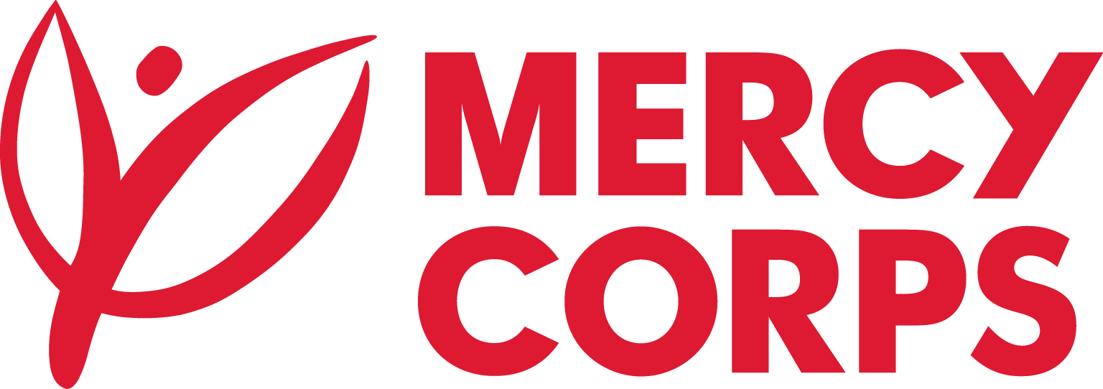
Date: 16-July-2024
TENDER NOTICE
Mercy Corps is a non-religious, non-profit and non-governmental international humanitarian organization. Mercy Corps is powered by the belief that a better world is possible. Across the more than 40 countries in which we operate, we are working to address root causes of poverty head on and helping those caught in crisis not only meet their immediate needs but build a brighter future.

Mercy Corps Kenya invites applications from qualified interested bidders for the services below.
No | Tender Number | Category | Deadline of Submission
1. | MCK-NBO-WTRWRK -024-009 | Benane Water project | 24th July 2024, 1700Hrs

If you are interested in submitting a bid, you will need to complete an Intent to Bid Form (ITB) and Supplier Information Form (SIF) and submit it according to the guidelines below.
- Suppliers can download the Intent to Bid Form and Supplier information forms at https:/www.mercycorps.org /tenders
Completed Intent to Bid Forms and supplier information form must be submitted to Mercy Corps by 24th July 2024@1700hrs according to the guidelines below.
- Email completed Intent to Bid Form and supplier information form to tenders.mck@mercycorps.org with the Tender Reference number above in the email subject line.
N/B: Please don’t send any bids or proposals with the Intent to Bid Form.
Complete Tender Package will be shared with those who submitted on time the following:
1- Signed and stamped ITB (Intent to Bid)
2- Signed and stamped Supplier Information Forms (SIF)

After the closing date of this Tender Notice, the Request for Bid/Request for Proposal will be sent to the suppliers who submitted Intent to Bid Forms and the supplier information form. The Request for Bid will be sent according to the preference you have mentioned in the Intent to Bid Form.

