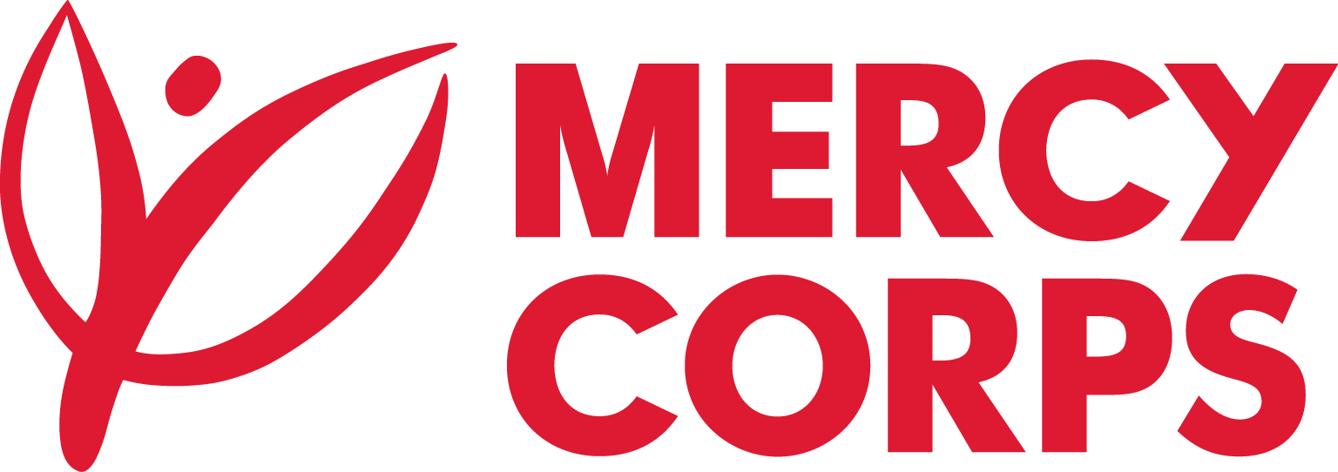
Date: 8-9-24
Reference: ET01/PR129193/2024

Tender Notice
Mercy Corps is a non-religious, non-profit and non-governmental international humanitarian organization.

Mercy Corps is seeking an international pharmaceutical supplier for the humanitarian assistance for conflict affected populations program in Afar and Oromia regions in Ethiopia.

If you are interested in submitting a bid, you will need to complete an Intent to bid and supplier information form and submit it according to the guidelines below.
- The suppliers can download the Intent to Bid and supplier information Form on this link https://www.mercycorps.org/tenders or
- Intent to bid form can be requested through the email address et-tender-questions@mercycorps.org.
Completed Intent to Bid and supplier information Forms must be submitted to Mercy Corps by [Aug 15, 2024, 5:00 PM EAT] in one of the below methods.
- Email completed Intent to Bid Form to et-tender-questions@mercycorps.org with the Tender Reference number in the email subject line. or
- Return completed Intent to Bid Form in person and put in the Tender Box placed at Mercy Corps office [Addis Ababa, Ethiopia Hayahulet Gollagul Square - AFRO Building, Addis Ababa Office +251 111 0777]. The Tender Reference number should be written in the envelope.
After the closing date of this Tender Notice, the Request for Bid will be sent to the suppliers who submitted Intent to Bid Forms. The Request for Proposal will be sent according to the preference you have mentioned in the Intent to Bid Form.

